COMMUNICATIONS UPDATE
communicate@blackburn.anglican.org


A selection of news stories from around the Diocese

Bishop Geoff retires
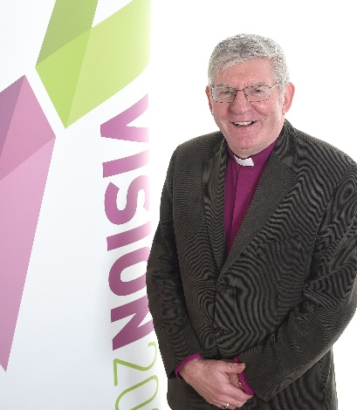
After 11 years as Bishop of Lancaster, Bishop Geoff Pearson retires this weekend … well, Monday July 31 to be exact! You may have seen the coverage related to his retirement on the Diocesan website and our various social media channels. Pieces have also appeared in local newspapers and on BBC Radio Lancashire – the station even edited together his career highlights along with a specially recorded interview to create a 30-minute programme entitled ‘A Bishop’s Life’!
Here are some key links …
- Personal reflections: Website story
- ‘A Bishop’s Life’ (courtesy BBC Radio Lancashire)
- Retirement service coverage: Website story; highlights video on YouTube; pictures on Flickr
Bishop Geoff also recorded a short farewell interview recently. As well as promoting the coverage above, you may also like to play this video (about 3 minutes) at your service this Sunday if you are able to do so. This is the YouTube version or you can download the video using this Dropbox link for playing offline if your church doesn’t have wifi. Please also share the YouTube version with family and friends and remember to subscribe to our channel for more videos while you are there.
Bishop’s Bible Challenge
With the challenge completed by 3000 children this has been a great success. Bishop Geoff was sprinting for the finishing line and personally presented more than 2000 of the children with their certificates, visiting schools across the Diocese in June and July. Read more here.
New Bishop of Lancaster
Bishop Julian wrote to the Diocese in mid-July with an update on plans for the new Bishop of Lancaster, now we have been given the go-ahead to appoint a new Bishop by the Dioceses’ Commission. Read that letter here.
New Deacons and Priests
Since the last update, when we trailed the ordinations which were about to take place, our 18 new Deacons and Priests have now been ordained at services in Blackburn Cathedral. Congratulations to every one of them! The services followed several days on retreat at Whalley Abbey. Full coverage of the retreat and services, including two videos, can be found on the Diocesan website and you can also get to know them all a little better via this page of the website. Finally, for pictures of the retreat and the services you can visit the album on our Diocesan Flickr feed.

New Diocesan website
Feedback so far on the new Diocesan website has been really positive. You are enjoying the fresh new look, better functionality and clearer presentation of information. The new Diocesan website has been live for a few weeks now and you can read more here about how and why it has been developed. New content will continue to be added and the website will continue to be refined as it settles down. We will be running some more feedback focus groups in the autumn but, in the meantime, any useful comments you may have about functionality, content (or anything else) please email: dave.champness@blackburn.anglican.org, ronnie.semley@blackburn.anglican.org or communicate@blackburn.anglican.org
Thousands of youngsters in stadium celebration

Thousands of primary school children from church schools across Lancashire came together recently at a huge stadium worship event organised by St James, Lower Darwen, with support from the Diocese. Some 4,000 children and adults from schools throughout Lancashire were invited to the home of Blackburn Rovers, Ewood Park for a South African Cross Culture Event. Special guests were a group of missionaries from our link diocese of the Free State. After spending time in Blackburn the SA group moved to work with St Peter’s Church in Fleetwood and then All Hallows, Bispham. Read more about the event and the visit in the stories on our Diocesan website here and here.
Whalley Abbey gardening success
The Abbey, our retreat and conference centre, needed some TLC in the garden so manager Christine Nelson had an idea. Thanks to volunteers from Fleetwood parishes and elsewhere in the Diocese who responded to pleas for help in The See, the Diocesan magazine, and dug for free (getting board and lodgings in return) the Abbey grounds have now been spruced up! You can read the whole story here.
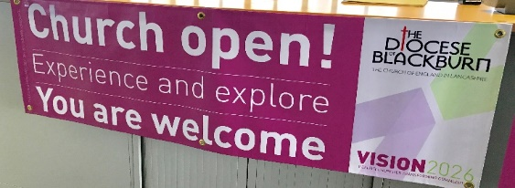
Banners to welcome visitors
Remember pre-designed welcome banners can still be ordered for inside or outside your buildings. The vinyl external banner (right) is £45 and internal pop-up banner is £99. Email karen.ashcroft@blackburn.anglican.org if you are interested, and to order.
… and finally
The final story for this Update is a nice piece about one of our churches (St Cuthbert’s in Lytham) where a simple but effective new scheme is reusing unwanted food via a new ‘community fridge’. If you are inspired to do the same thing in your church email communicate@blackburn.anglican.org and tell us!

Ronnie Semley
Diocesan Communications Manager
July 2017

